ICCR (Indian Council for Cultural Relations)

Getting Started Guide

ICCR
MINISTRY OF EXTERNAL AFFAIRS

Contents
1. Introduction 3
2. Mission Login 5
2.1 Applications Received 5
2.2 Processed Applications 6
2.3 Confirmation of University /Institute by HQRS 7
2.4 Acceptance /Decline by Applicant 7
2.5 Student/Research VISA Endorsement 7
2.6 Travel Plan of Applicant 8
2.7 Alumni 8

Introduction
The Indian Council for Cultural Relations (ICCR) is an autonomous organization of the Government of India, involved in India’s external cultural relations, through cultural exchange with other countries and their peoples. It was founded on 9 April 1950 by Maulana Abul Kalam Azad, the first Education Minister of independent India. Its objectives are to actively participate in the formulation and implementation of policies and programmes pertaining to India’s external cultural relations; to foster and strengthen cultural relations and mutual understanding between India and other countries; to promote cultural exchanges with other countries and people; and to develop relations with nations.

Open the URL: http://a2ascholarships.iccr.gov.in/ in any browser or device to access the “ICCR” application.
The Home page will appear:
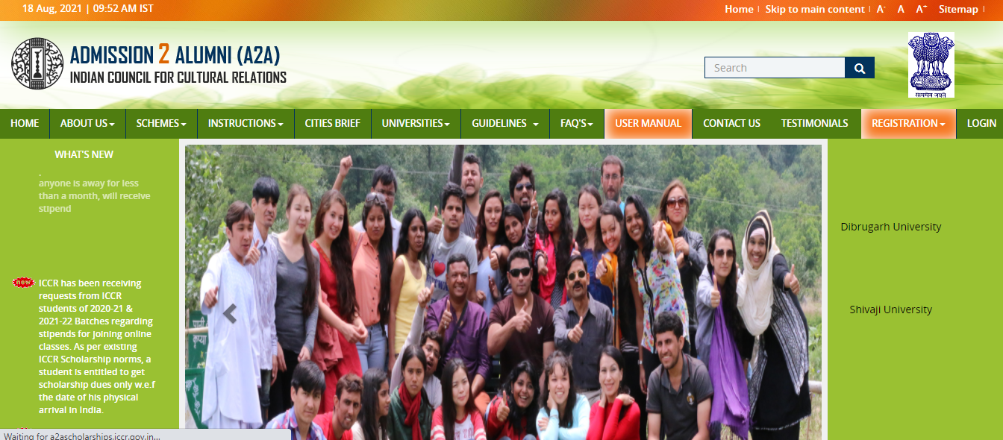
Home Page contains following menu:-
- Home
- About Us
- Schemes
- Instructions
- Lists
- Guidelines
- Contact Us
- FAQ’s
- Register
- Login
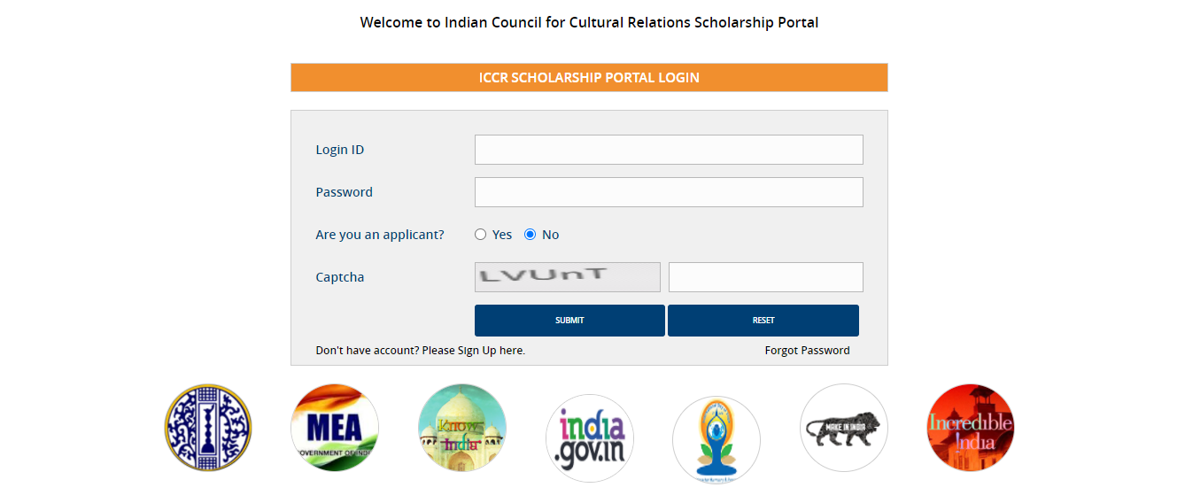

- After successfully login with Mission User, following dashboard will be displayed as shown in screen below:

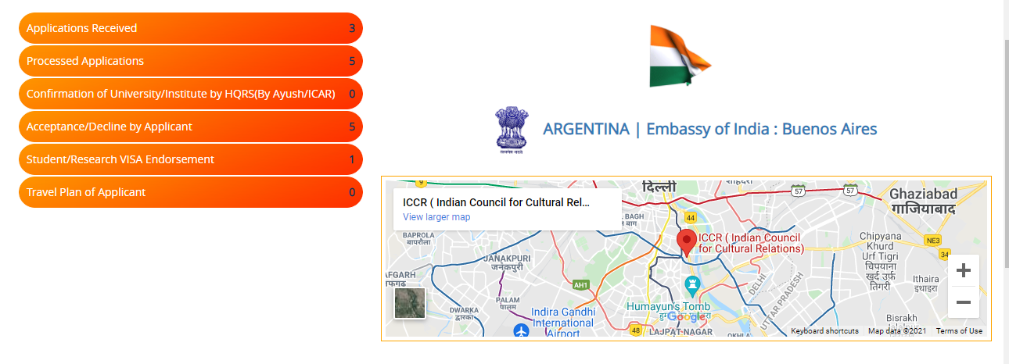
Following Side Menus have been provided on Dashboard

Application Received
Process Application
Confirmation of University/Institute by HQRS AYUSH/ICCR
Acceptance Decline by Applicant
Student/Research Visa
Travel Plan of Applicant

Application Received: -
Application processed by university will appear here.
- Click on Application Received

- List of Applications received will appear

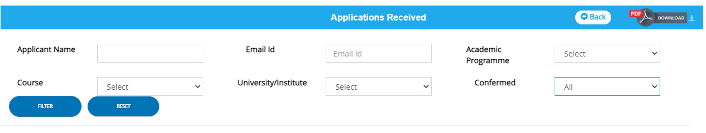

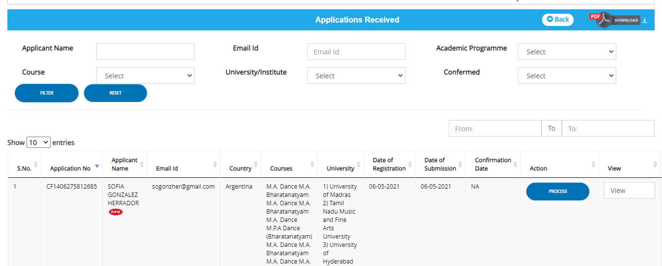

- Click on Process button (If confirmation uploaded by University the process button is active if not it is disabled).
- You can search applicant by name, email etc.
- You can search all confirmed application by Universities: -Select confirmed all and then click on FILTER button.

- Popup message shows are you confirm click on yes.

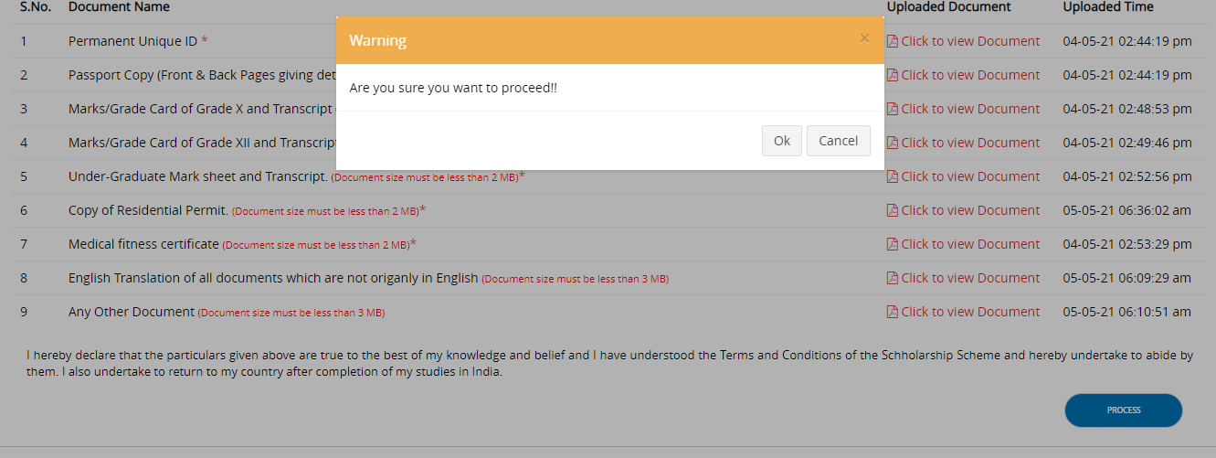

- Check all check points and mission can see all universities confirmation in this screen
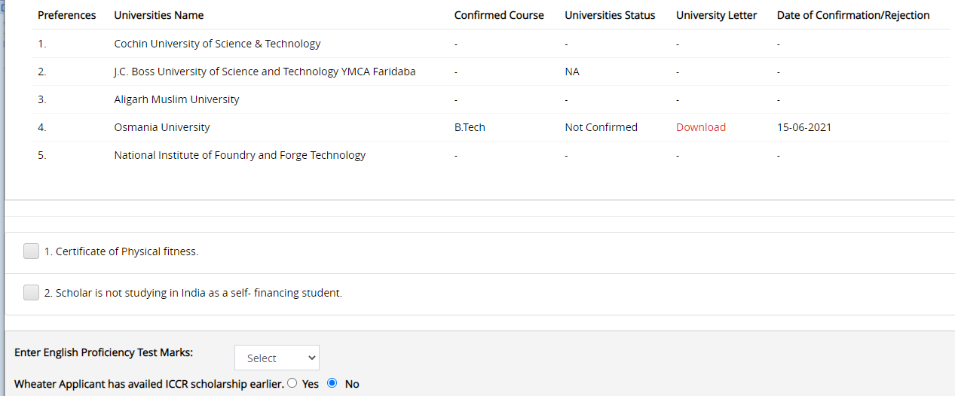

- Click on Scholarship confirmed yes ,select University and select scholarship programmed(Scheme)
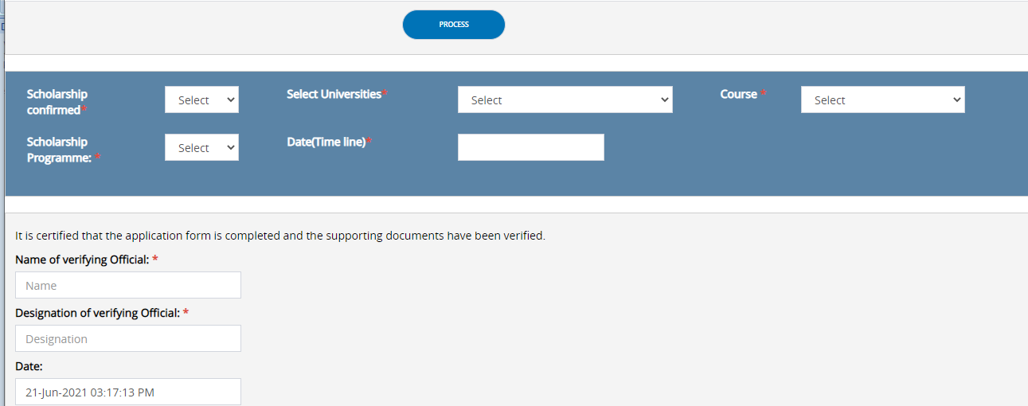

- Fill designation and place and upload signature
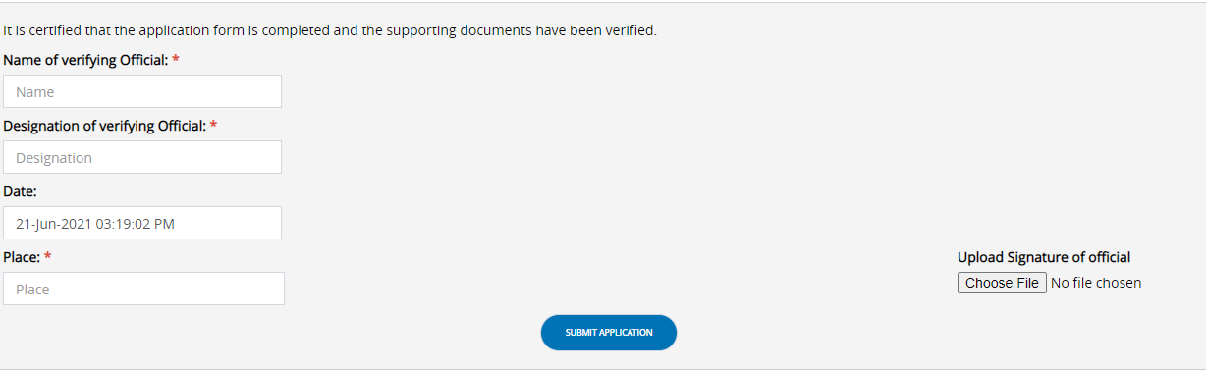

- Click on submit and a popup message shows the application recommended by mission.

- Go to the Process tab and click on the View button and download the Offer letter

Process application
Through this tab mission can see processed application
- Click on “Process application

List will appear.
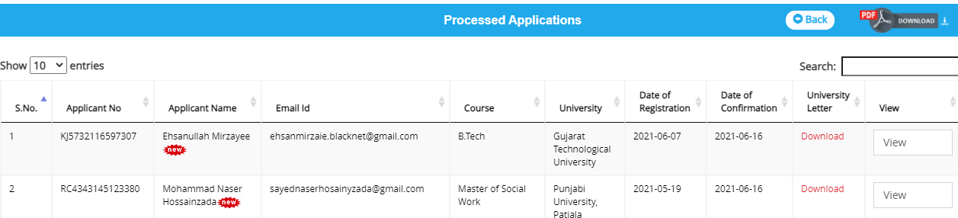
- Click on “View”, Application form will appear along with university letter and ICCR letter
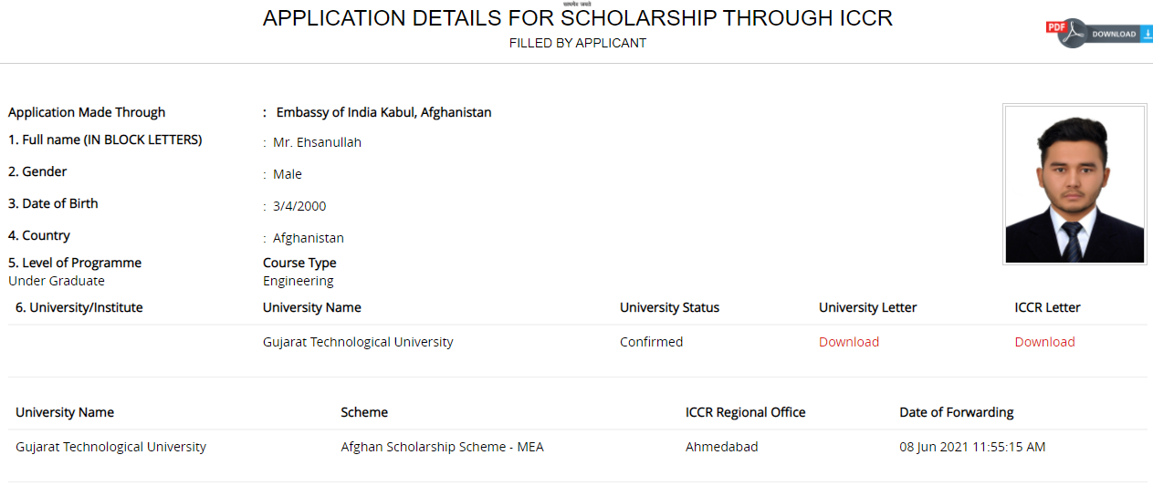

Confirmation of University/Institute by HQRS AYUSH/ICCR

Through this tab mission can see confirmation of University by HQRS (AYUSH/ICCR) application

Acceptance/Decline by Applicant

- Applications acceptance/declined by applicant, will be displayed here

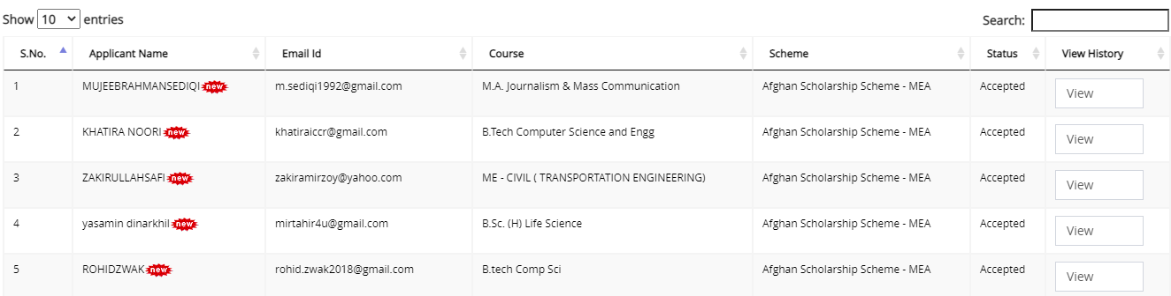

Click on “View”, Application form will appear along with university letter and ICCR letter and acceptance letter

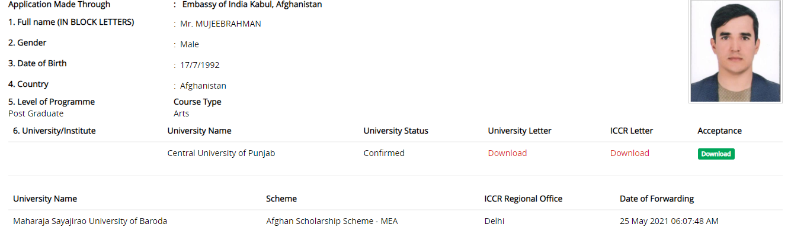

Student/Research VISA Endorsement

- List of student visa details, will be displayed here.
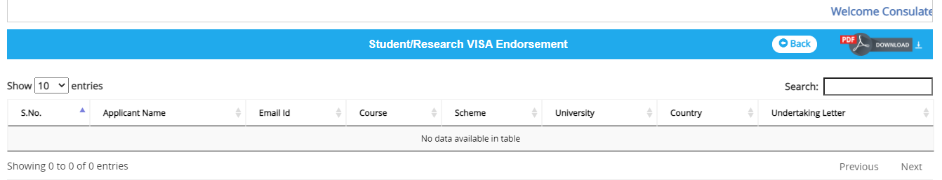

Travel Plan of Applicant

- List of student travel plan details ,will be displayed here

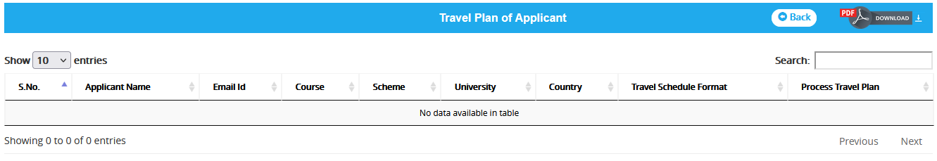

Alumni

- List of alumni details, will be displayed appear.

